Chocolate Rating Prediction Using Multiple Regression Models
G.Jasmitha Tejaswini
Vignan University
jasmithateju@gmail.com

Abstract - This paper presents a machine learning project that predicts chocolate bar ratings using the Flavors of Cacao dataset. The goal of the project was to compare how well different regression models could estimate a chocolate bar's expert rating based on features such as cocoa percentage, company location, and bean origin. The dataset was cleaned and preprocessed by handling missing values, removing duplicate rows, converting the cocoa percentage column to a numeric format, and encoding categorical variables using one-hot encoding. The data was then split into training and testing sets using an 80/20 split. Five regression models were trained and evaluated: Linear Regression, Ridge Regression, Lasso Regression, Random Forest Regression, and Gradient Boosting Regression. Model performance was measured using Mean Absolute Error, Mean Squared Error, Root Mean Squared Error, and the R-squared score. Among the five models tested, Random Forest Regression achieved the best overall performance, with the lowest error values and the highest R-squared score. This paper explains the preprocessing steps, the models used, and the results in simple terms suitable for a college-level machine learning report.
Index Terms - chocolate rating prediction, machine learning, model comparison, regression

I. INTRODUCTION
Chocolate quality can depend on many factors, including the percentage of cocoa used, the origin of the cocoa beans, and the company that manufactures the bar. This project explores whether machine learning regression models can predict a chocolate bar's expert rating using information available in the Flavors of Cacao dataset. The purpose of this report is to explain, in simple terms, the steps taken to prepare the data, the regression models that were trained, and how their performance compares using standard evaluation metrics.
Predicting a rating is a regression problem because the target value, Rating, is a continuous number rather than a category. Five different regression models were used so that their results could be compared fairly under the same preprocessing and train-test split conditions.

II. DATASET DESCRIPTION
The dataset used in this project is the Flavors_of_Cacao.csv dataset, which contains information about chocolate bars, including the company that produced the bar, the specific bean origin, the cocoa percentage, the company's location, the bean type, and an expert-assigned rating. The target variable for this project is the Rating column, which represents the quality score given to each chocolate bar.

III. DATA PREPROCESSING
Before training any models, the dataset was cleaned and prepared using the following steps:
- Column names were cleaned by removing extra spaces and newline characters.
- The dataset was checked for missing values and duplicate rows.
- Duplicate rows were removed from the dataset.
- The Cocoa Percent column originally contained a percent sign (%) as text; this symbol was removed and the column was converted into a numeric format.
- The REF column was removed because it is an identification/reference number and does not provide meaningful predictive information.
- Numerical and categorical features were identified separately using the select_dtypes() function in Pandas.
- Missing numerical values were filled in using the median of each column, and missing categorical values were filled in using the mode (most frequent value).
- Categorical variables (such as company location and bean type) were converted into numeric form using one-hot encoding with pd.get_dummies(..., drop_first=True).
- The resulting dataset was converted into float format so that all values were numeric and ready for modeling.
- Numerical features were scaled using StandardScaler so that all features contributed fairly to the models, particularly the ones sensitive to feature scale such as Ridge and Lasso Regression.
After preprocessing, the target variable (y) was set to Rating, and the predictor variables (X) consisted of all remaining columns after removing Rating and the REF column.

IV. EXPLORATORY DATA ANALYSIS
As part of the exploratory data analysis, a histogram was created to visualize the distribution of the target variable, Rating. This chart was used to check the overall shape of the rating values before modeling began. No additional exploratory visualizations were reported for this project.

V. TRAIN-TEST SPLIT
The dataset was divided into a training set and a testing set using an 80/20 split, meaning 80 percent of the data was used to train the models and the remaining 20 percent was used to test how well the models performed on unseen data. A fixed random_state value of 42 was used so that the split would be reproducible.

VI. REGRESSION MODELS USED
Five regression models were trained on the same training data and evaluated on the same testing data so that their performance could be compared under equal conditions. No separate hyperparameter tuning process, such as grid search or cross-validation, was performed; the parameters listed below were set directly when defining each model.

A. Linear Regression
Linear Regression is the simplest regression model. It tries to find a straight-line relationship between the input features and the target rating. It was used with its default settings and served as a baseline model for comparison.

B. Ridge Regression
Ridge Regression is a version of linear regression that adds a penalty term to reduce overfitting by shrinking large coefficient values. An alpha value of 1.0 was used for this project.

C. Lasso Regression
Lasso Regression is similar to Ridge Regression, but it can shrink some coefficients all the way to zero, which effectively removes less useful features from the model. An alpha value of 0.01 was used for this project.

D. Random Forest Regression
Random Forest Regression builds many decision trees on different random subsets of the data and averages their predictions. This approach usually reduces overfitting and can capture non-linear relationships between features and the target. It was configured with n_estimators=200 and random_state=42.

E. Gradient Boosting Regression
Gradient Boosting Regression builds decision trees one at a time, where each new tree tries to correct the errors made by the previous trees. It was configured with n_estimators=200 and random_state=42.

VII. EVALUATION METRICS
Four standard regression metrics were used to evaluate and compare the models:
- Mean Absolute Error (MAE): The average of the absolute differences between the predicted ratings and the actual ratings. A lower MAE means the model's predictions are, on average, closer to the true ratings.
- Mean Squared Error (MSE): The average of the squared differences between predicted and actual ratings. Because the errors are squared, MSE penalizes larger mistakes more heavily than MAE does.
- Root Mean Squared Error (RMSE): The square root of the MSE. RMSE is useful because it is expressed in the same units as the target variable (Rating), making it easier to interpret than MSE.
- R-squared (R²) Score: A measure of how much of the variation in chocolate ratings is explained by the model. An R² of 1.0 would mean perfect prediction, an R² of 0 means the model performs no better than simply predicting the average rating, and a negative R² means the model performs worse than predicting the average rating.

VIII. RESULTS
Table 1 shows the performance of all five regression models on the test set, evaluated using MAE, MSE, RMSE, and R² Score.
Table 1. Comparison of regression model performance
Model | MAE | MSE | RMSE | R² Score
Linear Regression | 0.429 | 0.301 | 0.549 | -0.302
Ridge Regression | 0.345 | 0.195 | 0.442 | 0.154
Lasso Regression | 0.368 | 0.226 | 0.476 | 0.022
Random Forest | 0.334 | 0.191 | 0.437 | 0.174
Gradient Boosting | 0.336 | 0.194 | 0.440 | 0.161

IX. DISCUSSION
The results show a clear difference in performance between the plain Linear Regression model and the other four models. Linear Regression produced a negative R² score of -0.302, which means it performed worse than simply predicting the average rating for every chocolate bar. This suggests that the relationship between the raw features and the rating is not well captured by a simple straight-line model, and that Linear Regression may have been affected by less useful or noisy features after one-hot encoding.
Ridge Regression and Lasso Regression, which both add a penalty to reduce overfitting, performed noticeably better than plain Linear Regression, with positive R² scores of 0.154 and 0.022 respectively. This supports the idea that regularization helped these models generalize better to the test data.
The two ensemble models, Random Forest and Gradient Boosting, achieved the strongest results overall. Random Forest recorded the lowest MAE (0.334), the lowest MSE (0.191), the lowest RMSE (0.437), and the highest R² score (0.174) among all five models. Gradient Boosting performed very similarly, with only slightly higher error values and a slightly lower R² score (0.161).

X. BEST PERFORMING MODEL
Based on the metrics reported in Table 1, Random Forest performed best among the tested models. It achieved the lowest MAE, MSE, and RMSE values, as well as the highest R² score, indicating that it produced the most accurate and most consistent rating predictions on the test data compared to Linear Regression, Ridge Regression, Lasso Regression, and Gradient Boosting.

XI. SAMPLE PREDICTION USING NEW/UNSEEN DATA
To test the practical use of the trained model, new chocolate bar data was provided to the selected Random Forest Regression model. The new data represents chocolate bars that were not used during the training of the model. The same preprocessing steps used during model training were applied to the new data to ensure consistency between the training data and the prediction data.
The trained Random Forest model was then used to estimate the rating of each new chocolate bar based on its available features. This demonstrates how the developed model can be used to predict ratings for previously unseen chocolate bars.

XII. PREDICTION RESULTS
The model generated a predicted rating for each new chocolate bar. The predicted values represent the estimated expert ratings based on the patterns learned from the original Flavors of Cacao dataset.
A graph was created to visualize the predicted ratings for the new chocolate bars. The graph makes it easier to compare the predicted ratings and observe the differences between the new samples.

XIII. INTERPRETATION OF THE PREDICTION
The predicted ratings provide an estimate of the quality rating that the Random Forest model expects for the new chocolate bars. Higher predicted ratings indicate that the model estimates better overall quality, while lower predicted ratings indicate relatively lower expected quality.
Since these are predictions for unseen data, the values should be considered estimates rather than exact expert ratings. The accuracy of the predictions depends on how similar the new chocolate bars are to the patterns present in the original training dataset.
Predicted Ratings for New Chocolate Bars
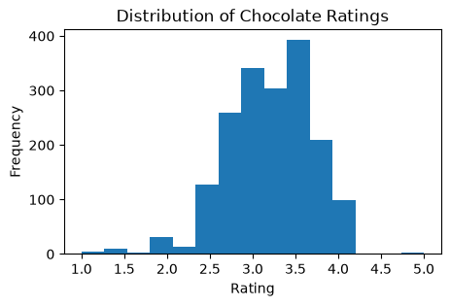

VIII. RESULTS

The R² scores of the five regression models were compared to determine how well each model explained the variation in chocolate ratings. Random Forest Regression achieved the highest R² score of 0.174, followed by Ridge Regression with 0.154 and Gradient Boosting Regression with 0.161. Lasso Regression achieved an R² score of 0.022, while Linear Regression produced a negative R² score of -0.302.

Figure 1 presents the comparison of R² scores for all five regression models. The graph shows that Random Forest Regression achieved the highest R² score among the models tested, indicating that it provided the best overall fit to the test data.

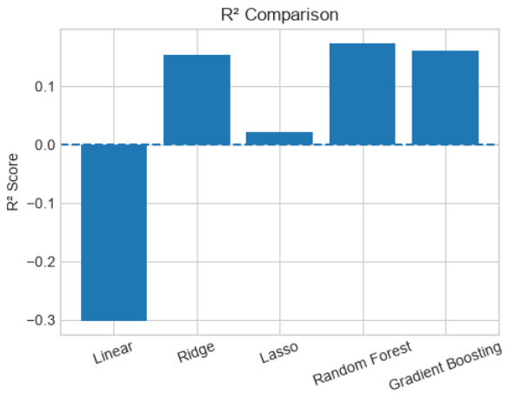

XI. LIMITATIONS
- The overall R² scores for all models remained relatively low (below 0.2), which means that even the best-performing model, Random Forest, was only able to explain a small portion of the variation in chocolate ratings.
- No hyperparameter tuning (such as grid search or cross-validation) was performed, so the reported results reflect only the specific parameter values listed in Section VI, not necessarily the best possible settings for each model.
- Only one exploratory visualization (a histogram of ratings) was created, so deeper patterns in the data, such as relationships between individual features and rating, were not explored in this project.

XII. CONCLUSION
This project applied five regression models to predict chocolate bar ratings using the Flavors of Cacao dataset. After cleaning the data, encoding categorical features, scaling numerical features, and splitting the data into training and testing sets, the models were compared using MAE, MSE, RMSE, and R² score. Random Forest Regression produced the best results among the five models tested, followed closely by Gradient Boosting Regression, while plain Linear Regression performed the worst, with a negative R² score. These results suggest that ensemble tree-based models are better suited to this dataset than simple linear models, likely because they can capture more complex, non-linear relationships between the chocolate bar features and their ratings.

XIII. FUTURE WORK
- Perform hyperparameter tuning (for example, using GridSearchCV) to see whether Random Forest or Gradient Boosting performance can be further improved.
- Add more exploratory data analysis, such as correlation plots between cocoa percentage and rating, to better understand which features influence the rating most.
- Explore feature engineering, such as grouping rare bean origins or company locations, to reduce noise introduced by one-hot encoding many categories.

REFERENCES
No external sources were cited in this project; the analysis was based entirely on the Flavors_of_Cacao.csv dataset and the Python code developed by the author.

ABOUT THE AUTHOR
G. Jasmitha Tejaswini is a student who completed this project as part of a machine learning course assignment, focusing on applying and comparing regression models using Python and Scikit-learn.

